1. **Customer Site**

This one is the landing page of customer as he browse through our hotel URL.  
Here, You can see different navigation bar of Home, About us, Menu, Reviews, and connect. Hereby, on the footer side you can see two buttons of Make a reservation and Take-away. So this is the home button interface.

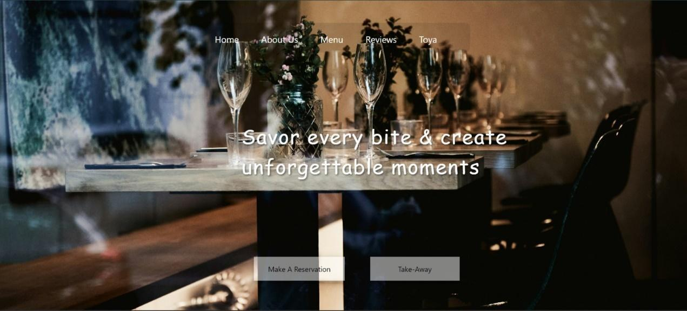

*Figure 33: Restaurant main page*

On browsing to about us, you can get to know more about the restaurant. You can see the feedback of green hover when you enter the about us page.

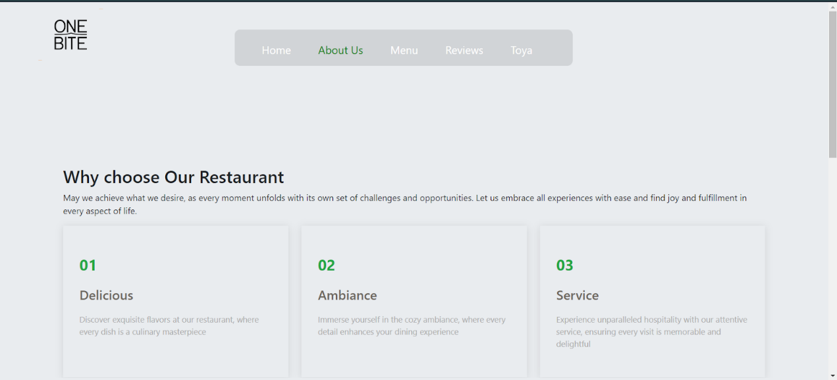

*Figure 34: About us Page*

Then on going menu, you can browse through different menu items available in restaurant.

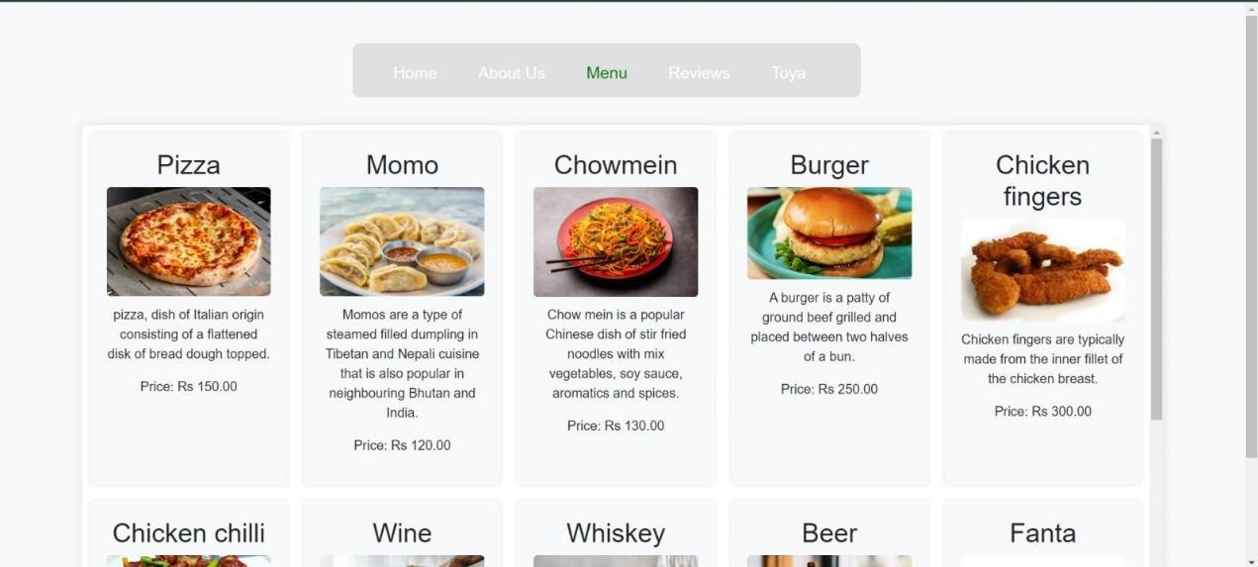

*Figure 35: Menu items*

On clicking review, you can get to know about the reviews given by our past customers visiting here.

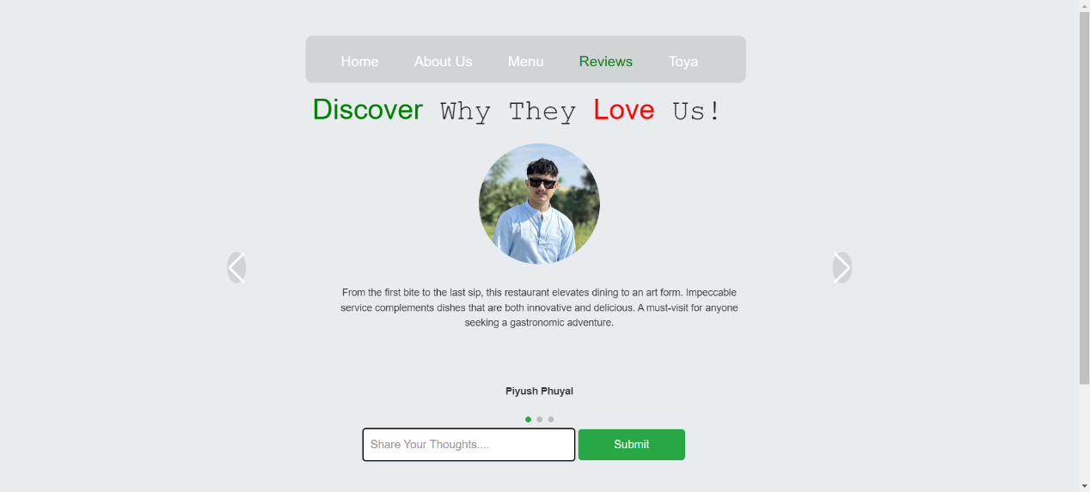

*Figure 36: Customer review*

The last section of nav bar is for your profile section. Here you can see your account login and in this site we have Toya logged in already.

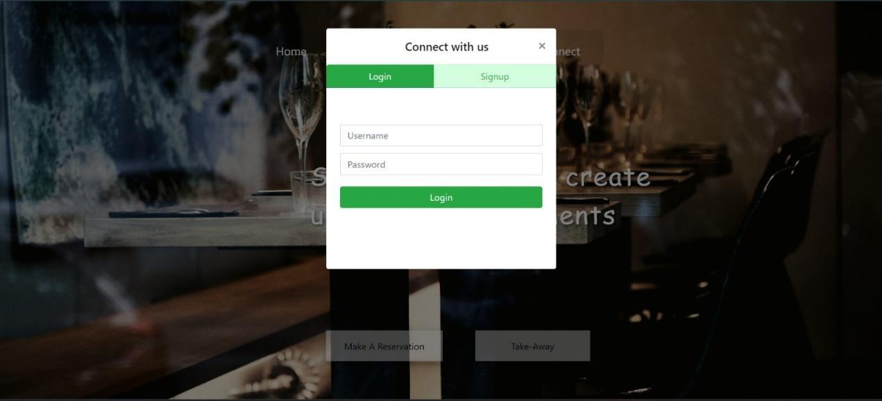

*Figure 37: Connecting to application*

You don’t have to log in to just browse in those nav bar. But for doing some actions you need to compulsory do login.  If you don’t have account, you can simply sign in to our system.

For Takeaway:

If you want to order food to takeaway you can follow these steps:

Step 1: Open the URL of restaurant

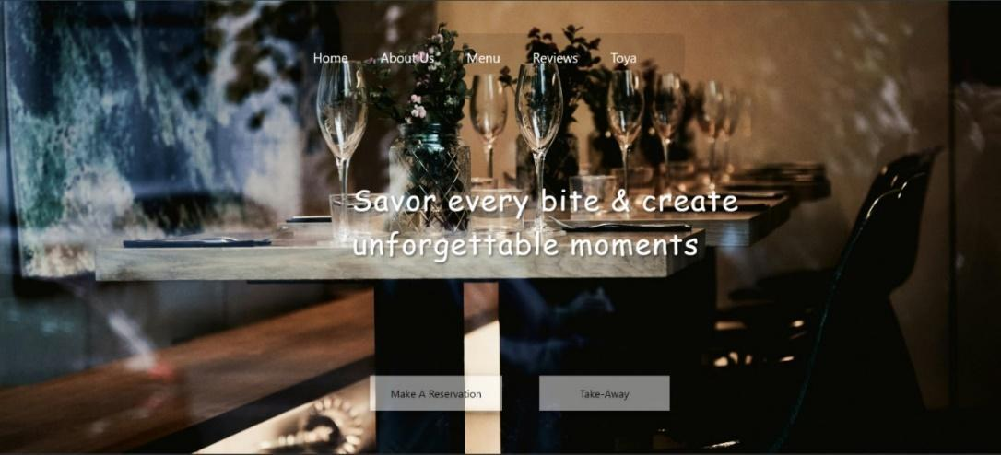

*Figure 38: takeaway 01*

Step 2: You can click on button takeaway. If you are accessing without login, the program will block your acess and ask you for login first.



*Figure 39: Login to continue*

Step 3: you will meet the take away interface

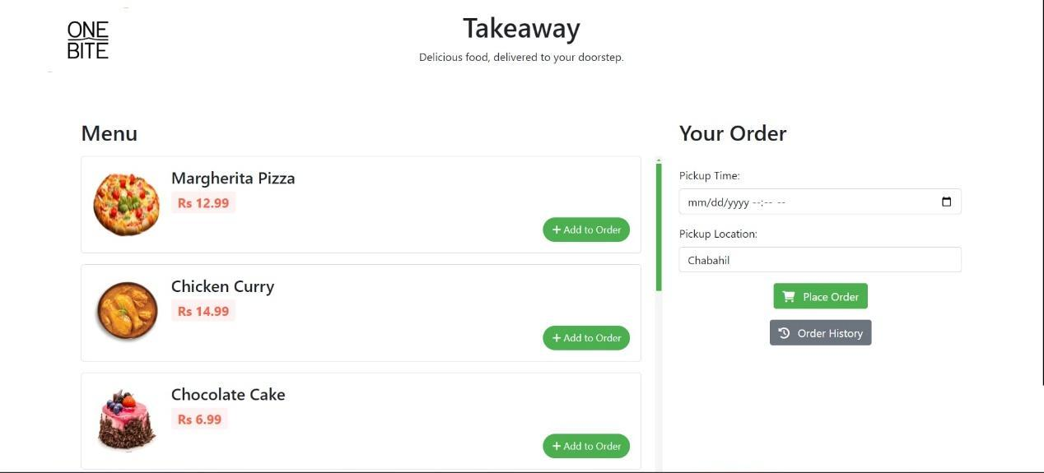

*Figure 40:  take away*

Step 4: You can scroll down menu and press on Add to order options on menu items as much plates you want to order.

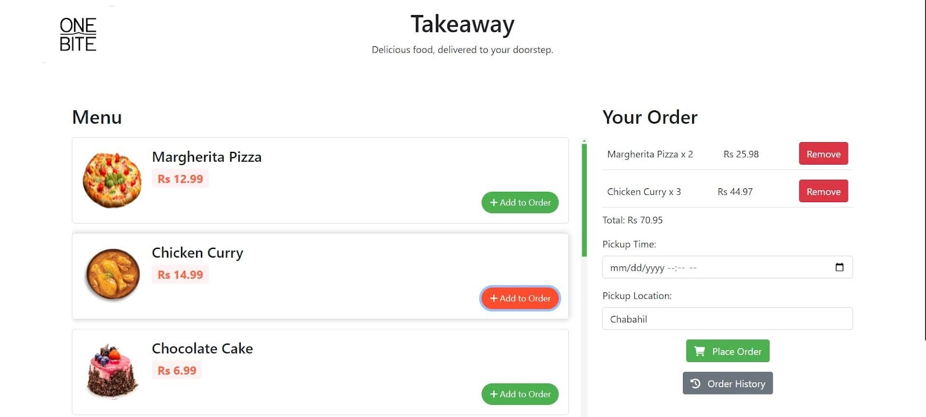

*Figure 41: Take away*

Step 5: You are restricted to add more than 5 order, if user needs some more items he can directly call us.

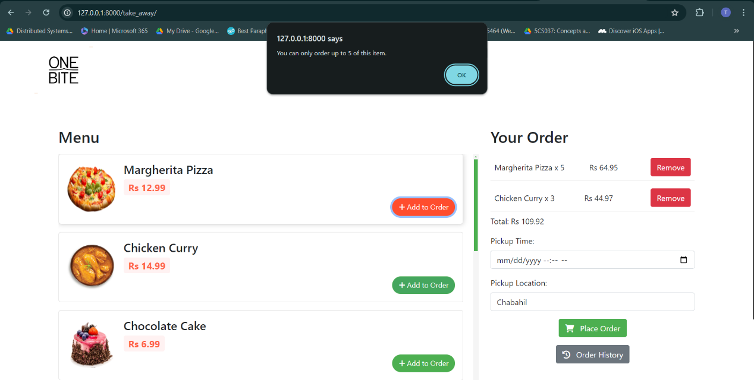

*Figure 42: Limitation in takeaway*

Step 6: You can then enter pickup time and pickup location and place order. You will be proceed to payment section with your order details in visual.

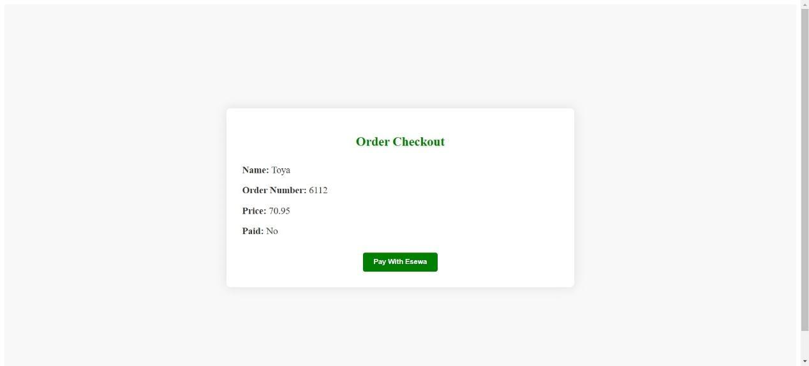

*Figure 43: Check Out*

Step 7: You can select option pay with Esewa and Esewa API will fetch an you can proceed your payment.  
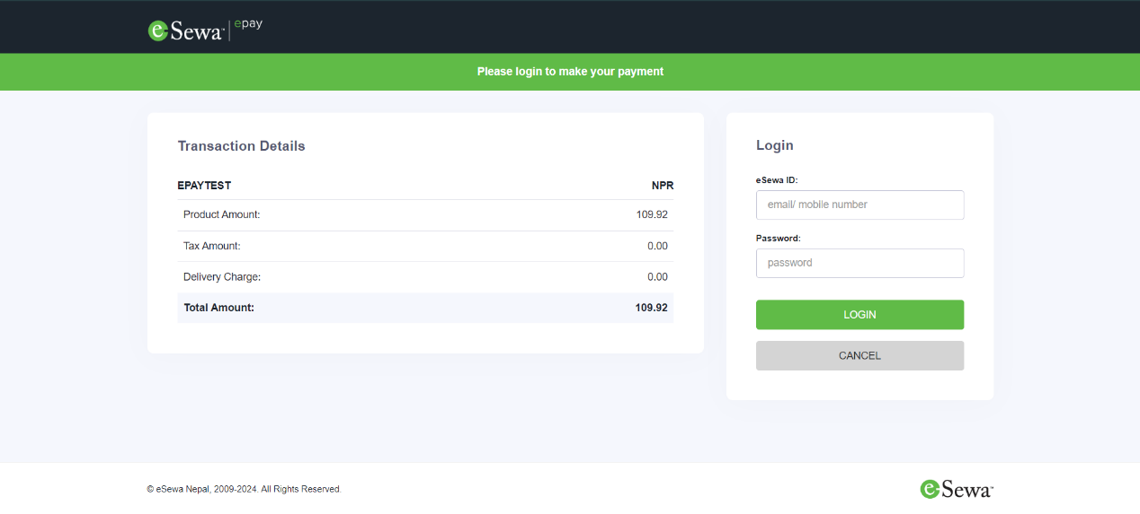

*Figure 44: E-sewa API*

Steo 8: If you cancel the payment section you can view your order in order history and you will got your option to payment along same way. The button of payment will not appear to those who completed the payment.

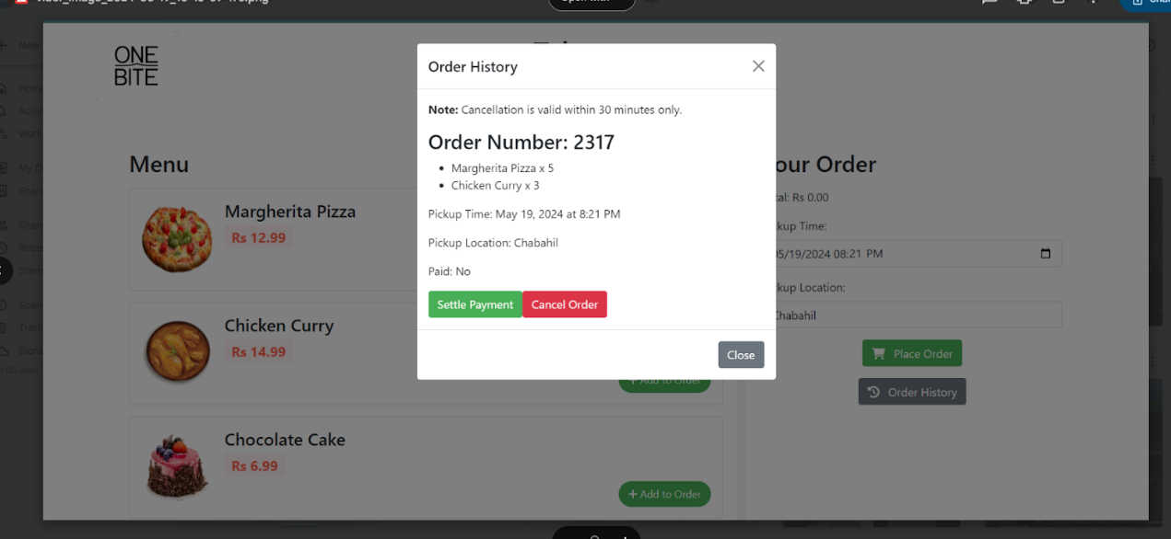

*Figure 45: Cancel payment case*

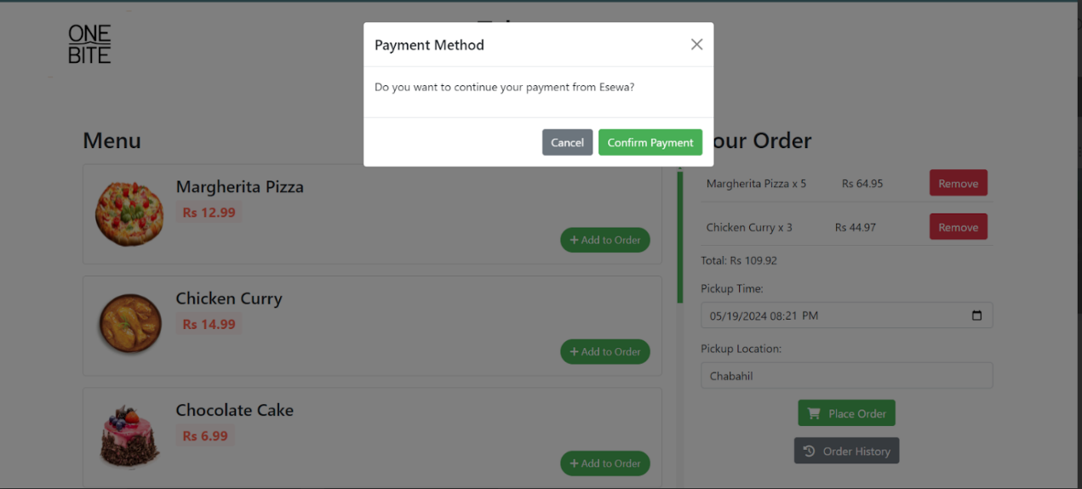

*Figure 46: Pay using esewa*

1. **Make A Reservation:**

Let me walk through you to reservation section

Step 1: Browse through restaurant  URL and click on make a reservation. Here also if your are not logged in system, program will force you to log in to system.



*Figure 47: Make a reservation*

Step 2: You will enter to reservation page.

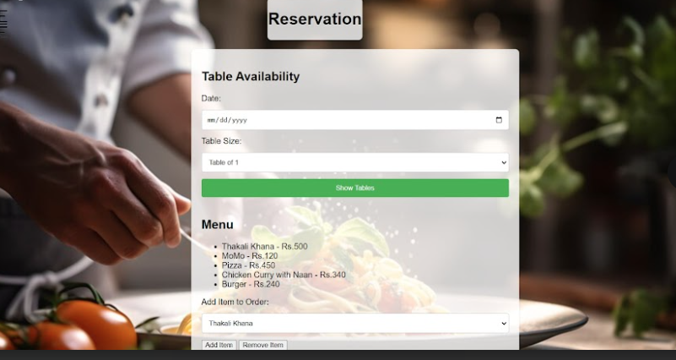

*Figure 48: Reservation 01*

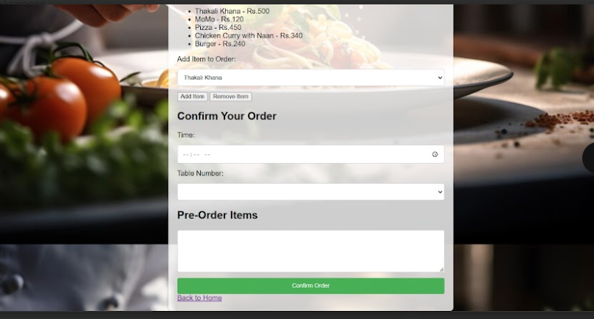

*Figure 49: Reservation 02*

Step 3 you can choose date and table size then click on show table, you will see green available table and red booked table.

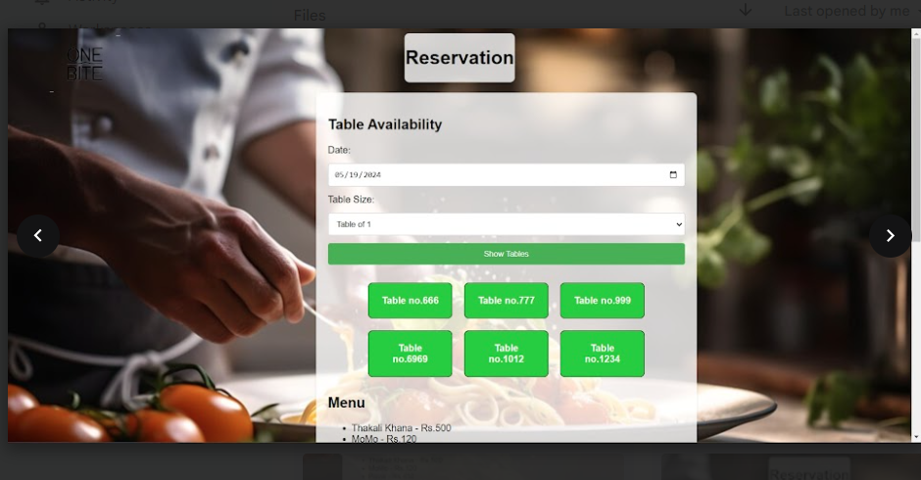

*Figure 50: Show table*

Step 4: You can enter the credsential and select the items you want to pre order and here also you are restricted for only 10 maximum plates. For higher you need to directly mail us.



*Figure 51: Reserve*

Step 5: After selecting items and inserting time, you can place your order into our staff side and the response will be sent through your mail about confirmation or rejection.

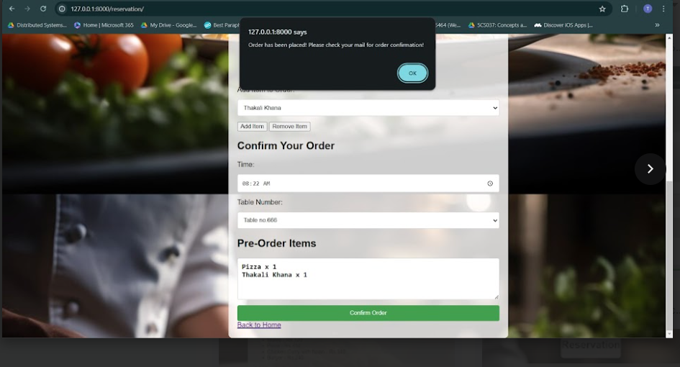

*Figure 52: Confirming order*

This much was for customer side.

Let me browse you to staff side:

Browse through the staff side URL, we have provided you with. Then connect to site from provided id password on dashboard you can view active reservation and active dine in orders. You can add table if necessary. Dine-in details will provide feedback on ongoing orders.

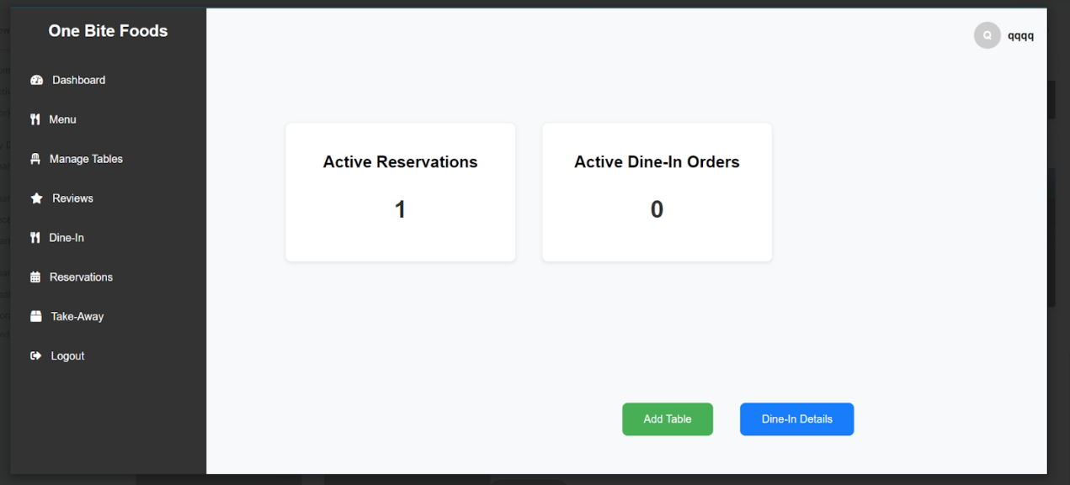

*Figure 53: Dashboard for staff side*

Click on add table option if you want to add table

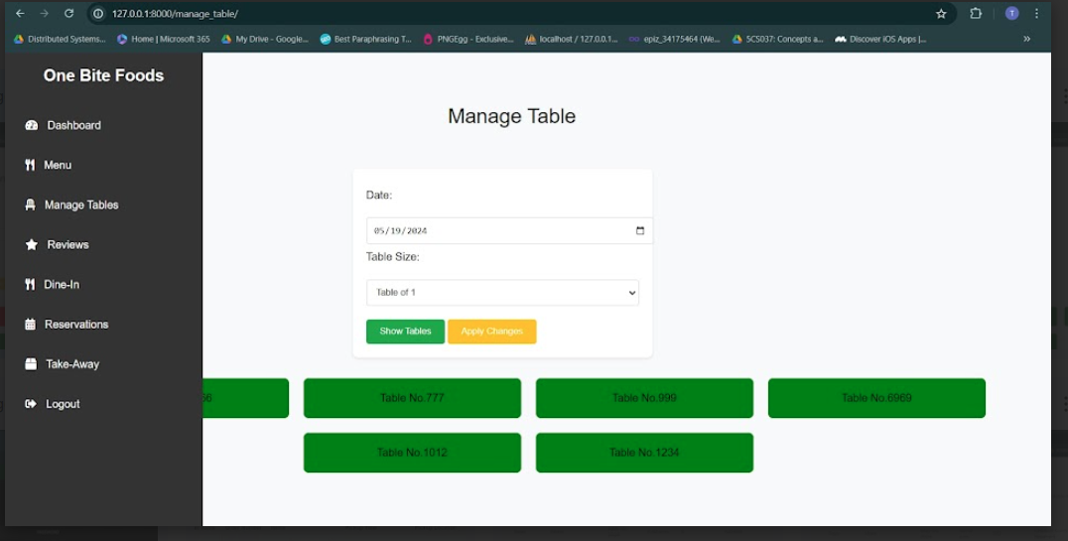

*Figure 54: Manage table*

Click on a table number and it color will change to red which represent booked. And the table will not appear in customer site.

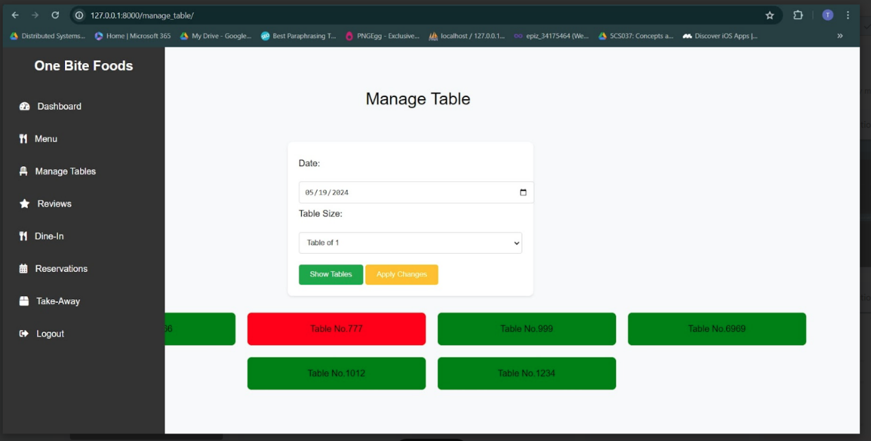

*Figure 55: Reserve option*

Click on apply changes:

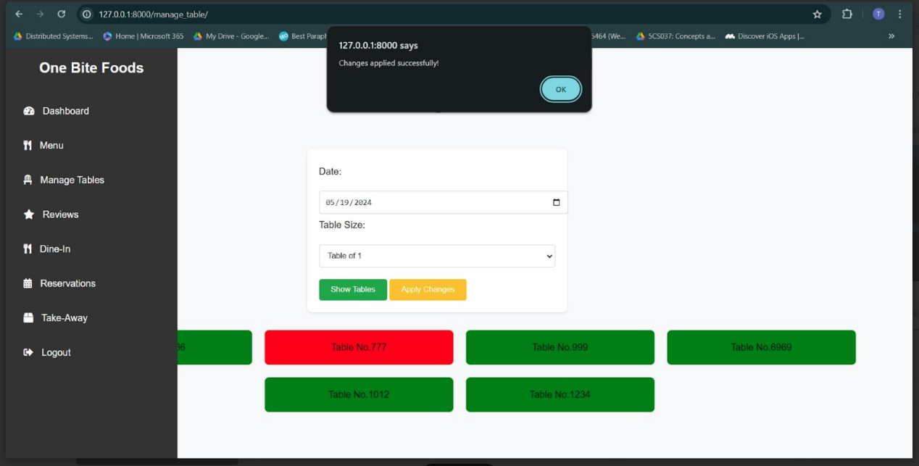

*Figure 56: Confirm table reserve*

Similarly, you can get back it to available table

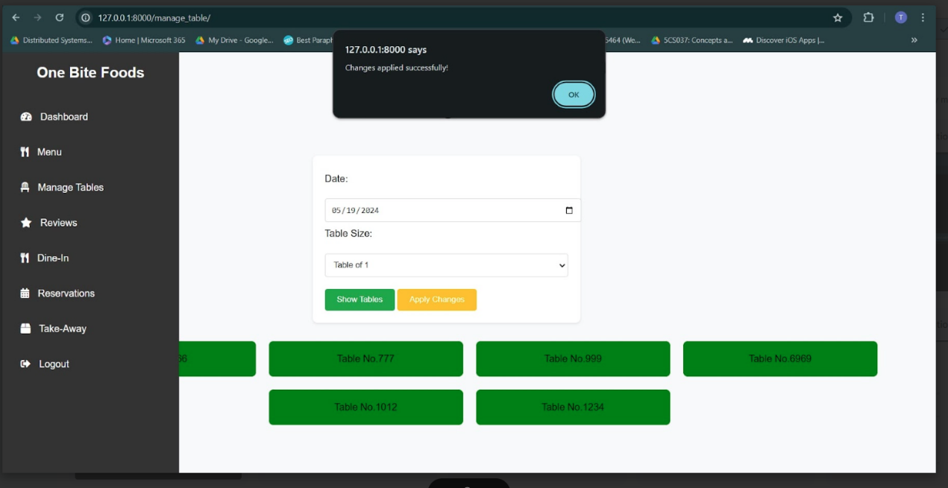

*Figure 57: Confirm table available*

Click on Dine in details to see ongoing dining orders.

Click on menu of navigation bar and view the items available in the restaurant. You can add and delete items here.

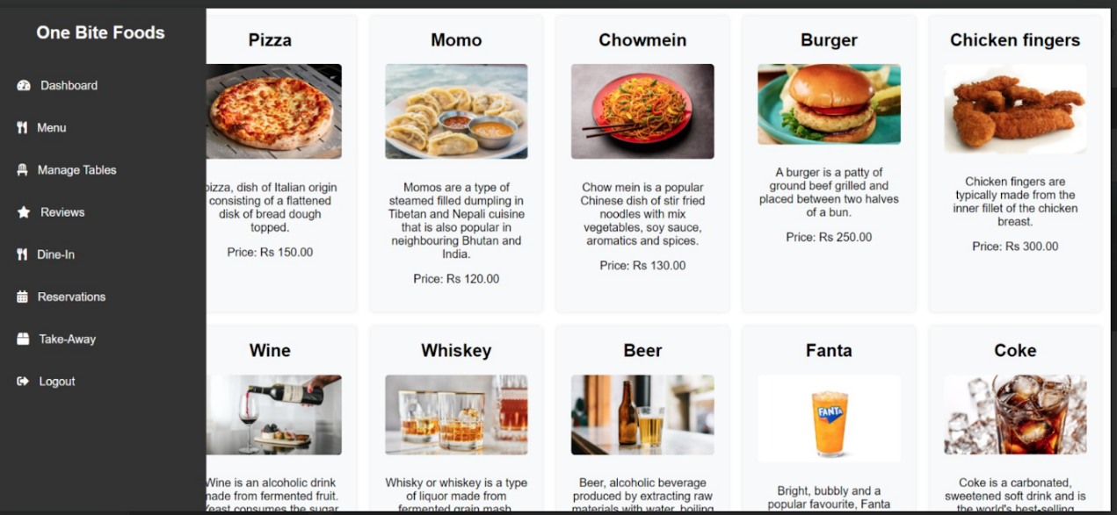

*Figure 58: Admin menu*

And on manage table section, you can alter the table condition from available to reserve and vice versa

In review section you can view the review given by customers.

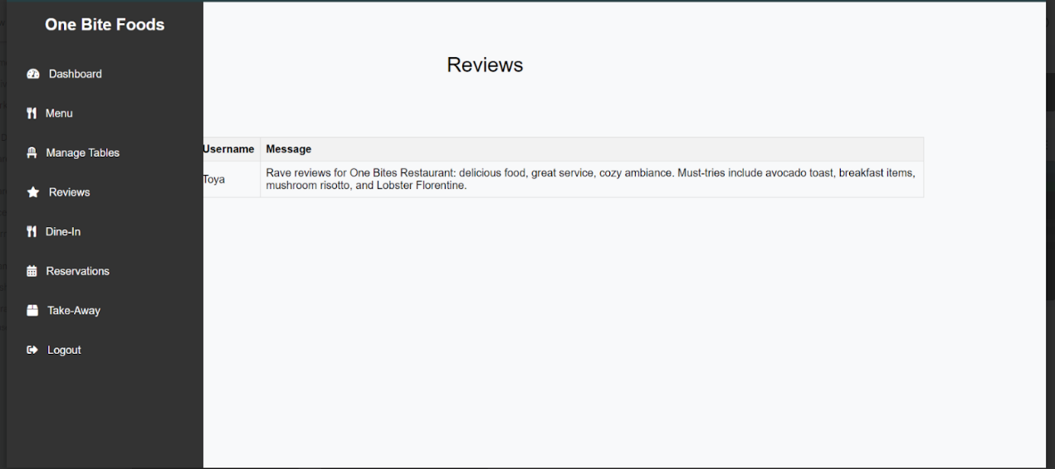

*Figure 59: Admin review*

In dine-in section you can manage the orders came for dine in

In reservation section you can manage the orders came for reservation. The dashboard look like this.

Step 1: The order from customer site are align on tabular format and have option to confirm, cancel and completed.

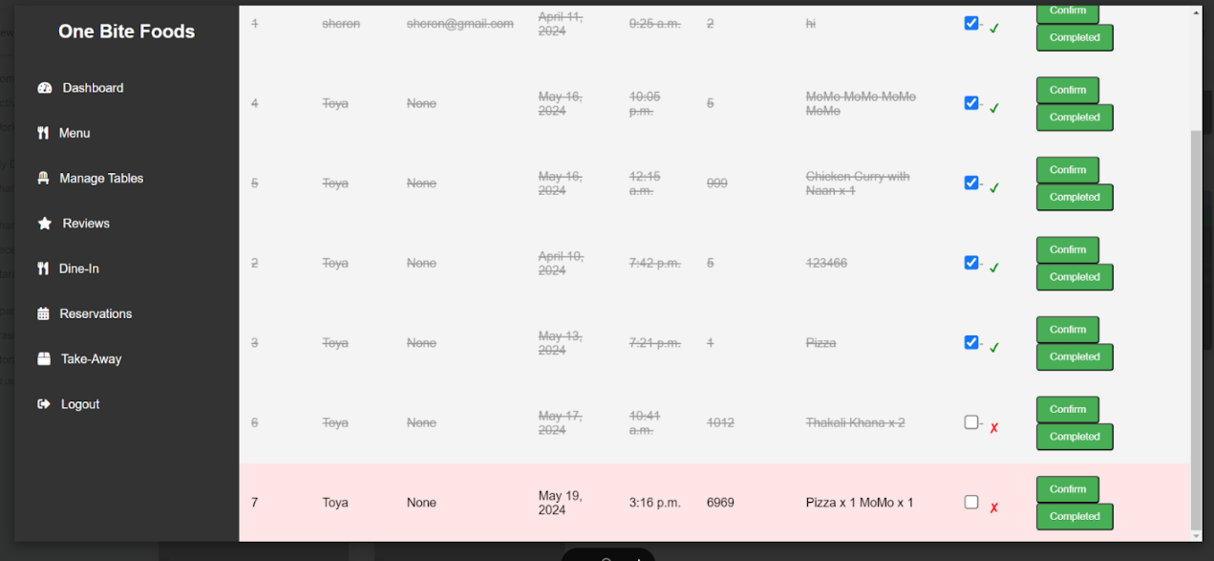

*Figure 60: Admin reservation page*

Step2: If the reservation is asked for cancelation you can click on red cross. And as the order come we browse to manage table section and see for table availability, and if table is available then you can click confirm and a confirmation mail is sent to user. \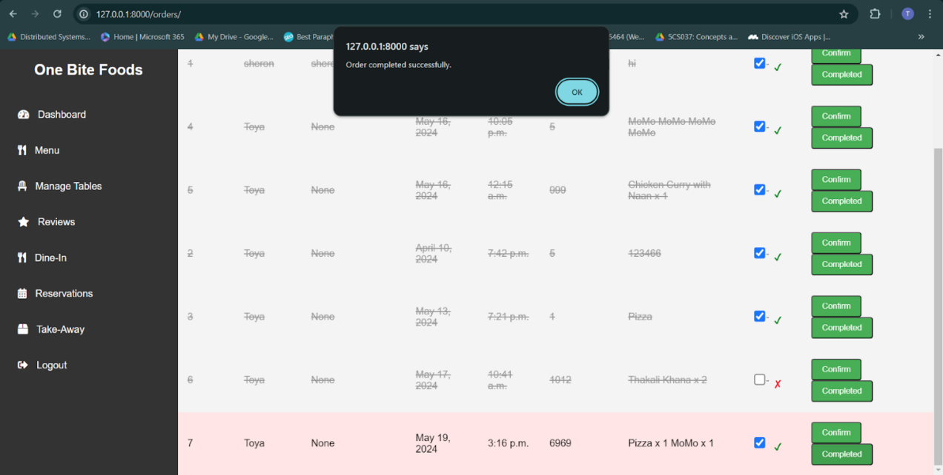

*Figure 61: Order confirm*

Step 3: After all eating and payment procedures are completed, you can click on completed and your order will be represented cut.

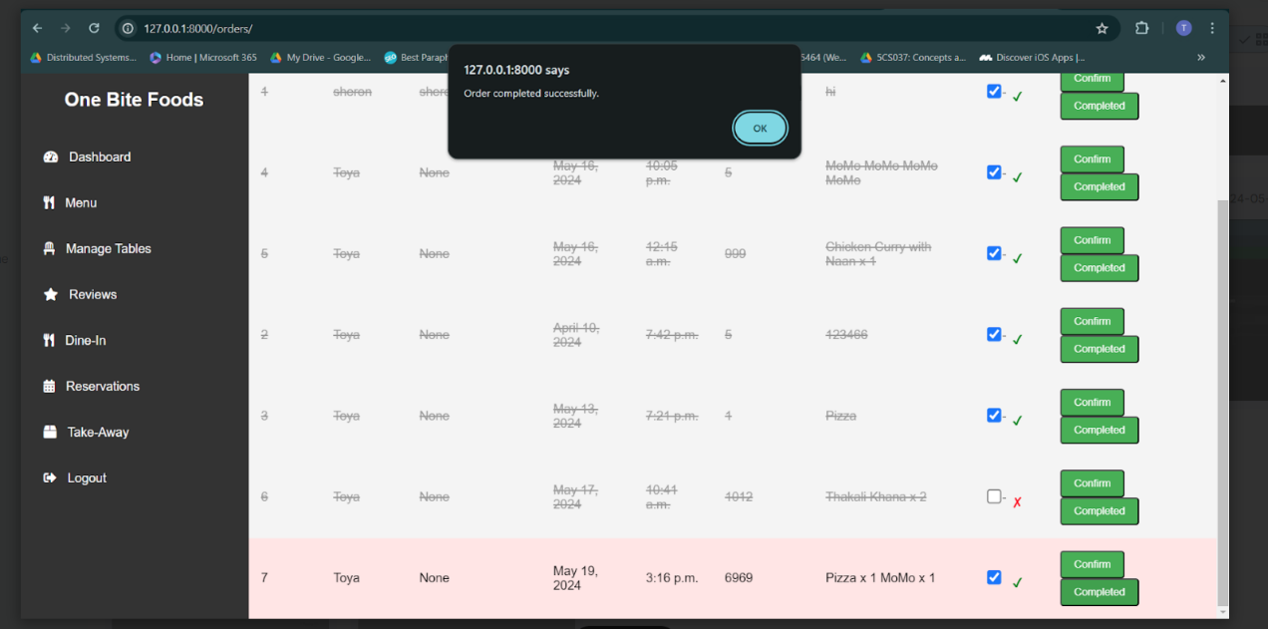

*Figure : Order completed*

Now next one is Take away section

Step 1: your takeaway interface in admin site look as this

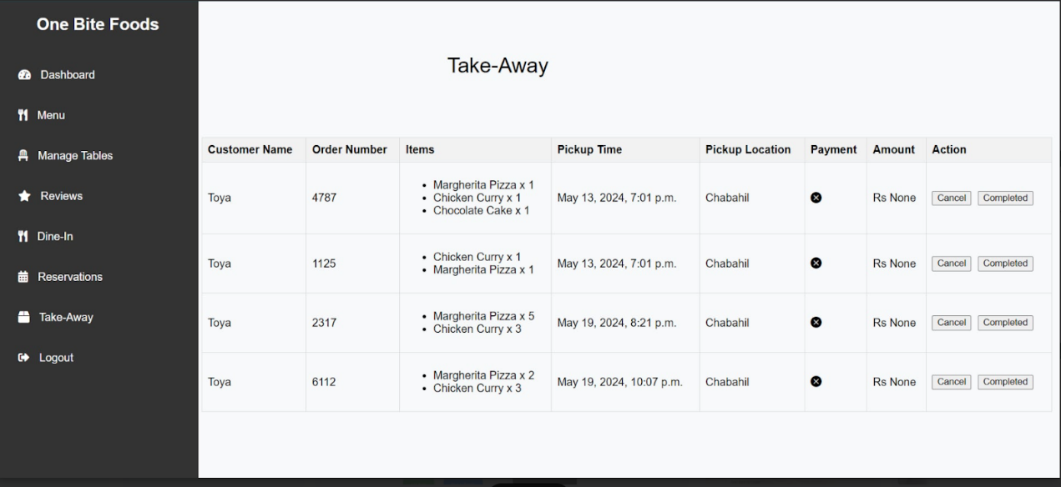

*Figure 63: Take away orders*

Here, we can complete the action once the food are taken by customer you can mark it as completed

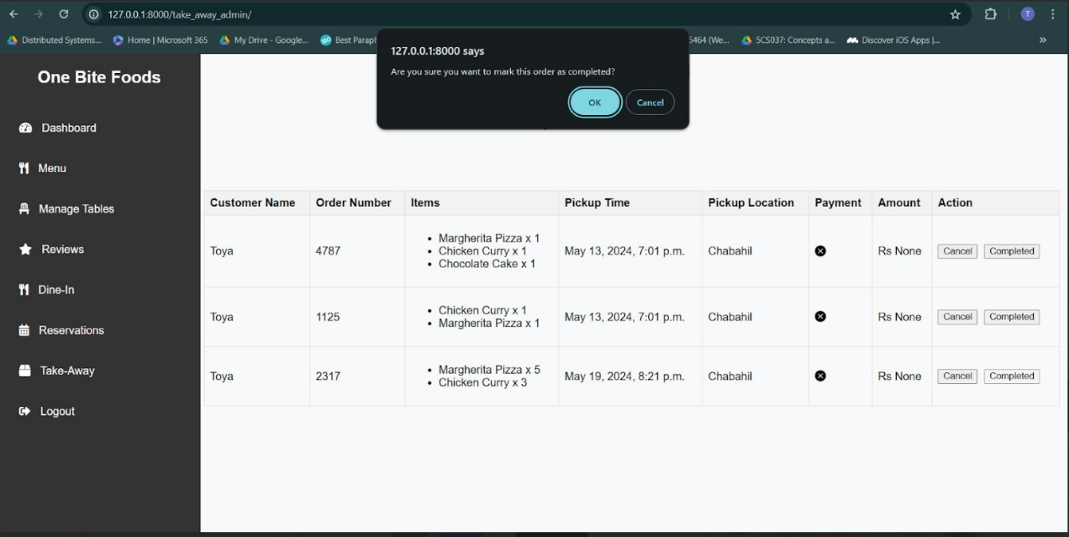

*Figure 64: Take Away complete*

You can also cancel the order prior to 30 minutes

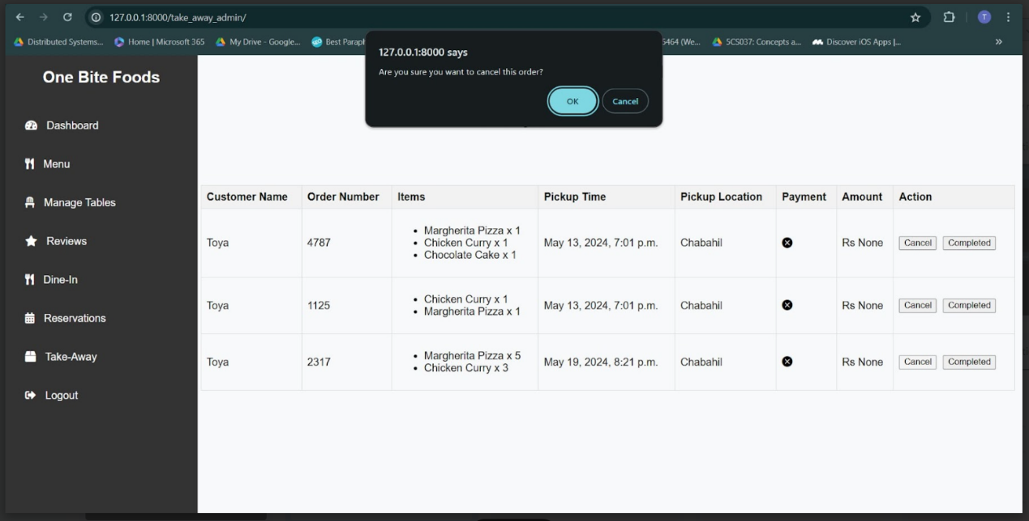

*Figure 65: Cancel takeaway*

Lastly you have option for log out. You can quit to login panel.

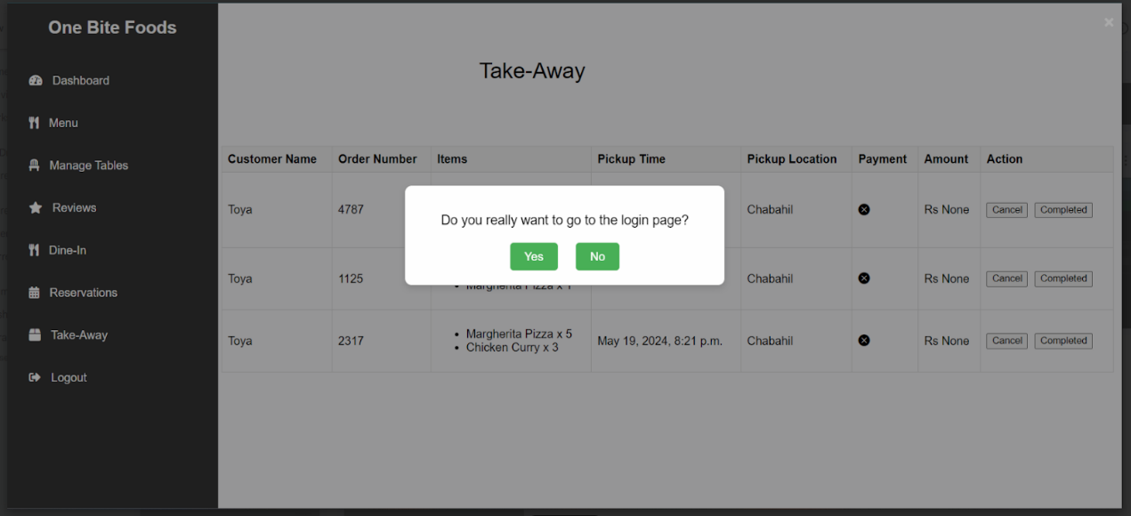

*Figure 66: Logout*

1. **Admin section**

Admin is the person who manage the staff section like add and remove them, and add and remove menu items and can view the sales report.

Step one: Browse to Staff section in admin interface and click on add button. And enter credentials.

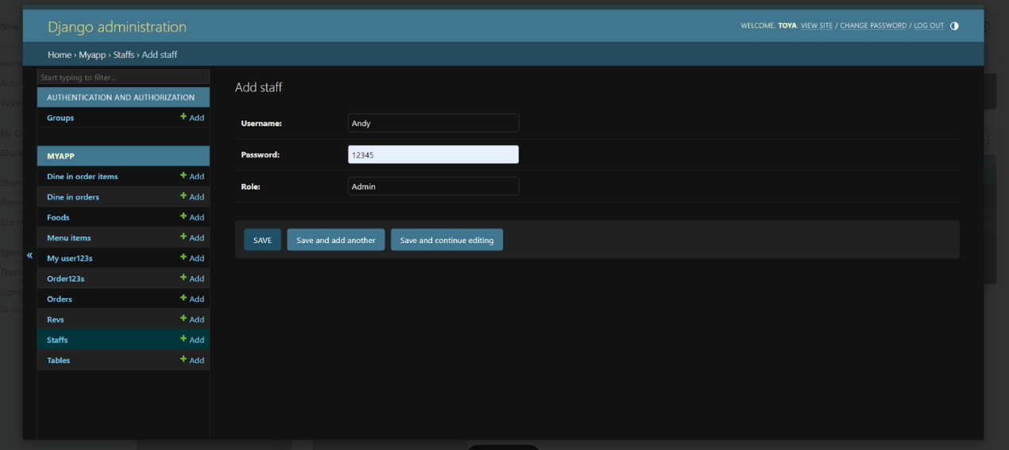

*Figure 67: Add staff*

Step 2: Click on save button and new staff will be added.   
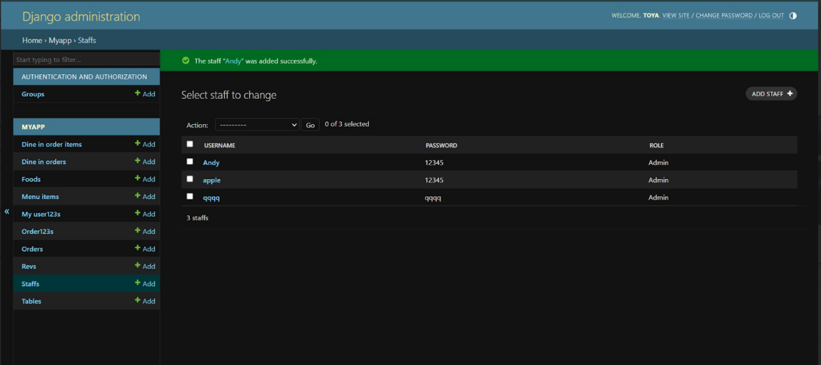

*Figure 68: Staff 01*

Step 3: You can select the staff name and choose option delete to remove the name.  
  
Another is we can add and remove menu items but the process is similar as the add and remove staff.

Step 1: Browse to menu items section

Step 2: Click on add section and add details for menu items and save it.

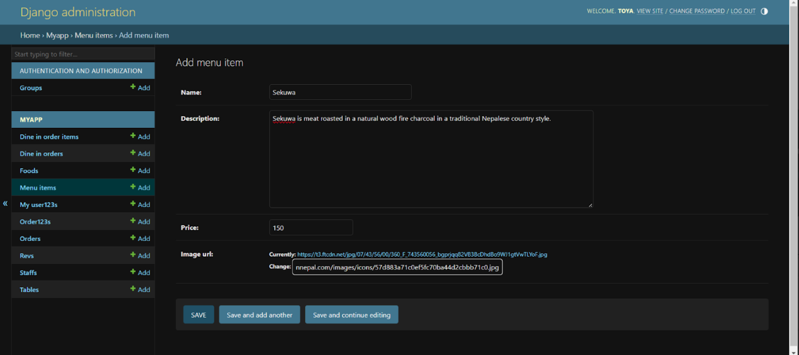

*Figure 69: Menu add*

Step 3: Similarly you can select one item and press remove option.

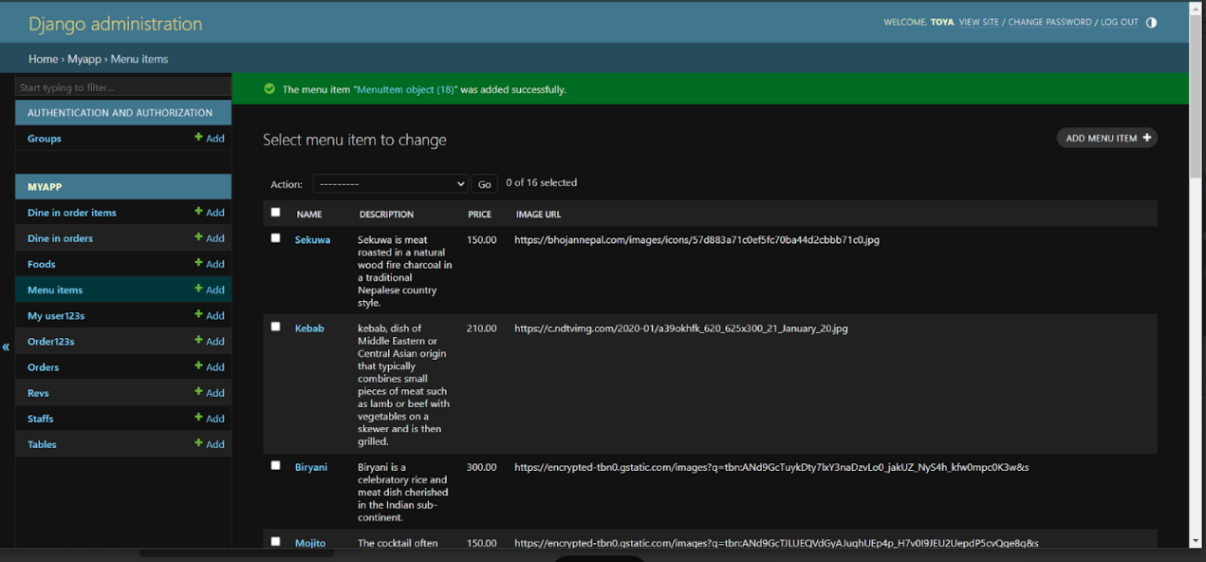

*Figure 70: Added menu*